Annexure – III

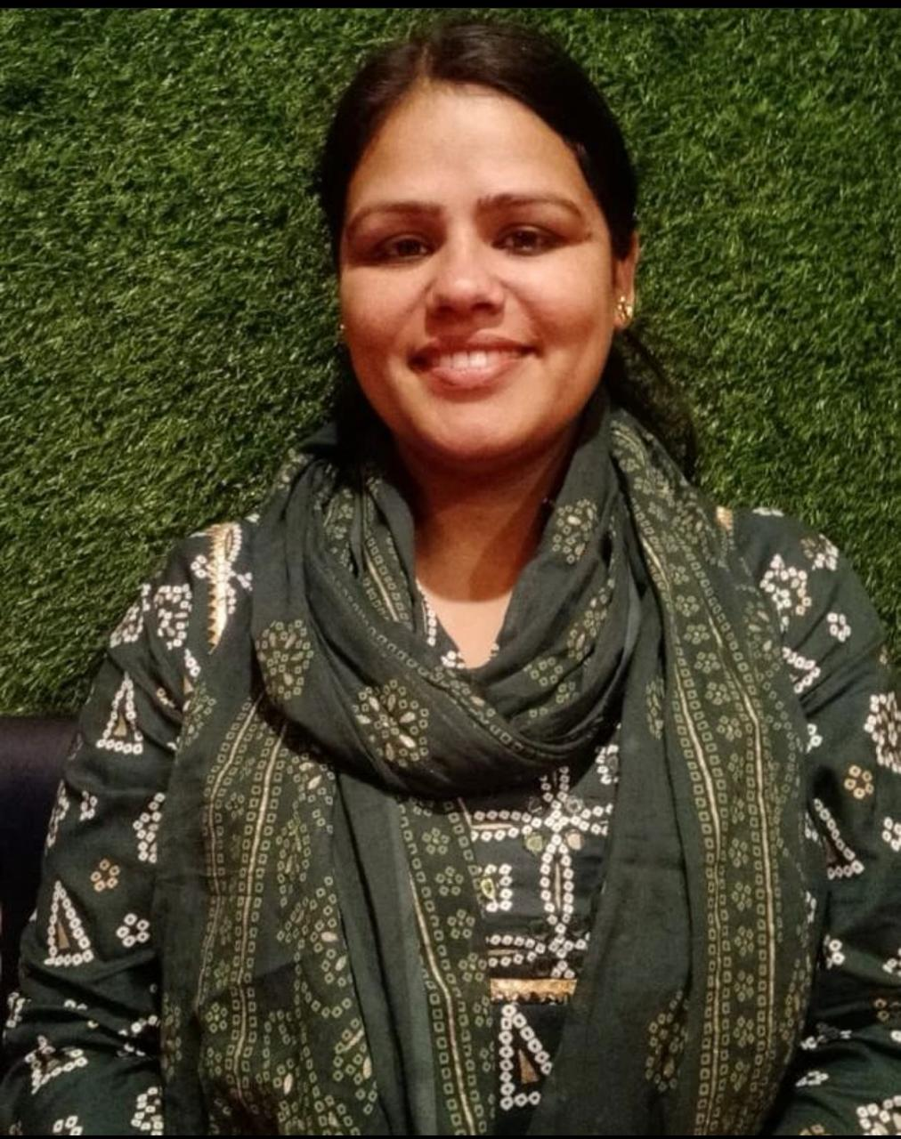

INDIAN COUNCIL OF SOCIAL SCIENCE RESEARCH
Research Projects Division

ICSSR Call for Research Projects on “Family and Family Systems in India” -(2025-26)
(Note: Insert additional rows wherever necessary)
Application number
(To be noted down from the online application)
Theme | Family and Family Systems in India
Sub-theme | Family, Society, and Institutions-Mental Health, Loneliness, and the Need for Strong Families
Title of the Research Proposal | Lives In Separation: A Longitudinal Analysis of Women’s Social and Psychological Adaptations in Migrant Households.  (long-term social and psychological impact of transnational migration on women)

BIODATA OF THE CO-PROJECT DIRECTOR/S

1 | Name of the Co-PD
 | a. Name  b. Designation  c. Department  d. Official Address  e. Contact No.  f. Email | a. Dr. Sunita Dhenwal  b. Assistant Professor  c. Psychology  d. Block 18, LPU, Punjab  e. 7014445361  f. Sunita.27978@lpu.co.in

2 | Educational Qualifications
 | Name of the Degree | Name of the University | Year of Passing / Award | % of Marks | Main Discipline
 | Master’s | JNVU, Jodhpur | 2007 | 77.80 | Psychology
 | M. Phil. | NA | NA | NA | NA
 | Ph. D. | JNVU, Jodhpur | 2021 | A√ | Psychology
 | Post-Doctoral | NA | NA | NA | NA
 | Title of the Ph.D. | Personality And Cognitive Correlates Among Male And Female Students Of Various Engineering Courses
 | Salient features of Ph.D. (in 100 words) | Personality refers to the set of behaviors, emotions, and cognitions shaped by biological and environmental factors. It influences discipline, punctuality, and thinking patterns, often linked with cognitive abilities like intelligence, aptitude, perception, and problem solving. This study, based on Eysenck’s personality theory, explored personality and cognitive correlates among 300 engineering students (150 males, 150 females) aged 18–24 in Jodhpur. Tools included the Introversion-Extraversion Test, Security-Insecurity Scale, Self-Concept Inventory, and Verbal Intelligence Test. Data were analyzed using descriptive statistics, ‘t’ tests, and correlations. Results revealed gender differences in self-concept, intelligence, security-insecurity, and personality traits, with notable intercorrelations across factors.

3. | Research Experience
 |  | Number | Title, role/capacity/Presentation/Participation and details of funding Institution
a. | Research Projects
b. | Fellowships | 1 | RGNF-JRF
c. | Ph.D. Guidance | 6 | 2 Completed
d. | M.Phil. Guidance | 0
e. | Seminars / Conferences | 17

4 | Details of 5 Best Research Papers/Books/Chapters (attach/submit hardcopies)
 | Title of the Publication | Name of the Journal / Book / Publisher | Month, Year and Vol. | Scopus / UGC CARE Listed/ Referred Journal
a | Parental Stress in Raising A Child with Special Needs Abroad: The Mediating Role of Financial Stress in The Relationship between Mental Well-Being and Parental Stress Among Indian Expatriate Parents in The UAE | International Journal of Basic and Applied Sciences | August 2025 and 14 | Scopus
b | The Interplay between Gender norms, Patriarchy and Mental health among Young Adults | International Journal of Interdisciplinary Approaches in Psychology | January 2025 and 3 | UGC CARE Listed
c | Impact of Interpersonal relationships and mental health on young indian expatriate workers in the middle east | Indian Journal of Psychology | 2024 and 12 | UGC CARE Listed
d | A comparative study of personality and stress between male and female in different employment | Naveen Shodh Sansar | 2014 and 2 | UGC Referred
e | Study of cognitive abilities and emotional stability in relation to age | Naveen Shodh Sansar | 2014 and 2 | UGC Referred

5 | Any other important academic achievement (approx. 100 words)
 | I have consistently excelled in academics, securing second position in Class 12th (Rajasthan Board) and in Master of Arts (Psychology) at Jai Narain Vyas University, Jodhpur. I qualified the RPSC-SET examination in Psychology with 84% and successfully earned my Ph.D. in Psychology on “Personality and Cognitive Correlates among Male and Female of Various Engineering Courses.” My academic journey is further marked by over 15 research publications in UGC Care and Scopus-indexed journals, multiple book chapters, and co-editing a book on Forensic Psychology. These accomplishments reflect my dedication to scholarship, research, and advancing knowledge in psychology.

6 | Whether Co-Project Director (Co-PD) received any financial assistance from ICSSR (mention last 2 awards) |  | Yes | √No
 | If yes:
 | Name of award/scheme
 | Name of the Co-PD
 | Year of Award
 | Amount sanctioned
 | Date of Completion, if completed
 | Date of Report submission, if submitted
 | (Add/insert additional rows for more information, if required)

Declaration

I hereby declare that:
- I am not a defaulter of any previous ICSSR grant.
- I have neither been subjected to any disciplinary action nor found guilty of any offence in my career.
- The Research Proposal and its contents are entirely original as per the standard ethical practices and no AI generated proposal have been submitted to ICSSR.
- I have not concealed any information in my application. If, ICSSR finds any contrary information at any stage, it may cancel the study out rightly and/or impose any penalty as it deems fit.

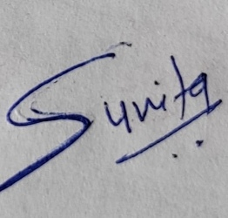
Place: Punjab
Date: 15/09/2025

Signature of the Project Director/
Co-Project Director (Co-PD)

